The funding has been provided to ensure impact against the following OBJECTIVE:
To achieve self-sustaining improvement in the quality of PE and sport in primary schools. It is important to emphasise that the focus of spending must lead to long lasting impact against the vision (above) that will live on well beyond the Primary PE and Sport Premium funding.
It is expected that schools will see an improvement against the following 5 key indicators:
Evidencing the Impact of Primary PE and Sport Premium -Guidance & Template-
Vision for the Primary PE and Sport Premium
ALL pupils leaving primary school physically literate and with the knowledge, skills and motivation necessary to equip them for a healthy, active lifestyle and lifelong participation in physical activity and sport
- the engagement of all pupils in regular physical activity – kick-starting healthy active lifestyles
- the profile of PE and sport being raised across the school as a tool for whole school improvement
- increased confidence, knowledge and skills of all staff in teaching PE and sport
- broader experience of a range of sports and activities offered to all pupils
- increased participation in competitive sport
Under the Ofsted Schools Inspection Framework 2015, inspectors will assess how effectively leaders use the Primary PE and Sport Premium and measure its impact on outcomes for pupils, and how effectively governors hold them to account for this. Schools are required to publish details of how they spend this funding and the effect it has had on pupils’ PE and sport participation and attainment.
Revised September 2017

Schools must include the following:
- how much PE and sport premium funding you receives for this academic year
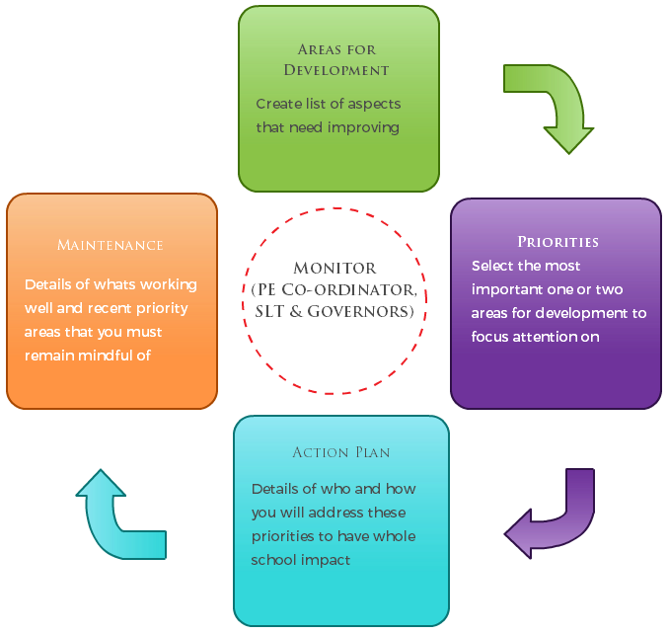
- a full breakdown of how you’ve spent or will spend the funding this year
- the effect of the premium on pupils’ PE and sport participation and attainment
- how you will make sure these improvements are sustainable
The published information should be clear and easily accessible and we recommend that you upload the following template (Annex 1) to your website for this purpose.
Improvements should enhance, rather than maintain existing provision. For example, where schools are using their funding to employ specialist coaches, these should be deployed alongside class teachers rather than displacing them, in order for their impact to be sustainable and to enable the upskilling of existing teachers.
Primary PE and Sport premium planning and actions should show how use of funding contributes to this vision through identified school priorities which can be measured through reference to key outcome indicators. It is important that the main drivers for improvement are those identified by the school through their self-review. Each school should aim to achieve the following objective:
OBJECTIVE: To achieve self-sustaining improvement in the quality of PE and sport in primary schools. Please see Figure 1 (above): A process model to support your thinking.

HOW TO USE THE PRIMARY PE AND SPORT PREMIUM
Schools must use the funding to make additional and sustainable improvements to the quality of PE and sport they offer. This means that you should use the premium to:
- develop or add to the PE and sport activities that your school already offers
- make improvements now that will benefit pupils joining the school in future years
For example, you can use your funding to:
- hire qualified sports coaches to work with teachers
- provide existing staff with training or resources to help them teach PE and sport more effectively
- introduce new sports or activities and encourage more pupils to take up sport
- support and involve the least active children by running or extending school sports clubs, holiday clubs and Change4Life clubs
- run sport competitions
- increase pupils’ participation in the School Games
- run sports activities with other schools
You should not use your funding to:
- employ coaches or specialist teachers to cover planning preparation and assessment (PPA) arrangements - these should come out of your core staffing budgets
- teach the minimum requirements of the national curriculum – including those specified for swimming.

Guidance on the primary PE and sport premium can be found at gov.uk.
Annex 1 – Primary PE and Sport premium – Online reporting template
Name of school: Kibworth Primary School
SECTION 1A – EVALUATION OF IMPACT/LEARNING TO DATE
Academic: 2019-2020
In previous years, have you completed a self-review of PE, physical activity and school sport? Yes
Have you completed a PE, physical activity and sport action plan/ plan for the Primary PE and Sport Premium spend? Yes
Is PE, physical activity and sport, reflective of your school development plan? Yes
Are your PE and sport premium spend and priorities included on your school website? Yes
SECTION 1B – SWIMMING AND WATER SAFETY self rescue focus.

Swimming is an important skill and can encourage a healthy and active lifestyle. All Local Authority schools must provide swimming instruction either in key stage 1 or key stage 2. The programme of study for PE sets out the expectation that pupils should be taught to:
- swim competently, confidently and proficiently over a distance of at least 25 metres
- use a range of strokes effectively [for example, front crawl, backstroke and breaststroke]
- perform safe self-rescue in different water-based situations.
Swimming and Water Safety | Please fill out all of the below:
• What percentage of your Year 6 pupils could swim competently, confidently and proficiently over a distance of at least 25 metres when they left your primary school at the end of last academic year? | 54% (of year 3 children assessed in December 2019)
• What percentage of your Year 6 pupils could use a range of strokes effectively [for example, front crawl, backstroke and breaststroke] when they left your primary school at the end of last academic year? | 52 % (of year 3 children assessed in December 2019)
• What percentage of your Year 6 pupils could perform safe self-rescue in different water-based situations when they left your primary school at the end of last academic year? | 54 % (of year 3 children assessed in December 2019)
• Schools can choose to use the primary PE and sport premium to provide additional provision for swimming but this must be for activity over and above the national curriculum requirements. Have you used it in this way? | Yes

Use the space below to identify what your use of the Primary PE and Sport Premium has been to date, and priorities for the coming year:
SECTION 2 – REFLECTION: WHAT HAVE WE ACHIEVED AND WHERE NEXT? 2019/ 2020

Key priorities to date: | Key achievements/What worked well: | Key Learning/What will change next year:
INCREASED PARTICIPATION/ INCREASED COMPETITIVE OPPORTUNITIES  - Continue to offer a range of activities and engage pupils taking part in extracurricular activities  - To introduce fencing as an extracurricular activity.  - To introduce and develop ‘Sports Champions’ (1 to 1 physical interventions for those children who’s fitness levels/weight levels require intervention. Also SEN children with physical needs ( Cerebral Palsy)  - Targeted groups – to develop a physical/movement intervention programme  - Continue to take part in LSLSSP/School Games competitions and local leagues. Next year to: continue enter B/ C teams into competitions to raise participation levels. To achieve School Games Gold Mark award.  - Continue to provide opportunities for children to take part in competitive sport  Project Gals. Girls as a focused group to take part in extracurricular clubs.  CONTINUED PROFESSIONAL DEVELOPMENT, AND ENSURING HIGH QUALITY PE LESSONS.  - To ensure all PE teaching is good or outstanding  - To improve staff CPD/Subject knowledge  - To continue to focus on use of assessment in PE. And how this impacts on planning  To continue to develop role of coordinator and build up a PE subject leader file.  KICK STARTING HEALTHY ACTIVE LIFESTYLES AND INCREASED PHYSICAL ACTIVITY  - To develop sports Ambassador and play leaders role to provide more lunchtime sports opportunities.  - To provide lunchtime sports activities in each key stage | - Children’s interests taken into account to offer a varied range of sports. Clubs/activities offered every day after school, except Fridays. On average there are 4 to 5 clubs on offer each day. There is a club available for a child from any year group e.g. yr 5 & 6 yr 3 & 4 years 1 & 2 each day.  - Introduced new sport to school PE curriculum – archery (£499.61 spent, £100.39 remaining balance)  - All pupil premium children were given the opportunity and were encouraged to take part in extra curricular activities. Clubs free of charge (ex. Tennis).  - A range of activities available to children – basketball, football, girls football, gymnastics, cricket, rugby, tag rugby, athletics, KS1 multi sports, netball, dance.  - New clubs were introduced - archery, golf  - 42% pupils taking part in afterschool clubs (autumn term 1 & 2 data)  (Evidence - club registers)  - Champions club – 1 to 1 physical interventions for children who’s fitness level/body weight require intervention  - Intervention programme was planned and took place for children who had been highlighted as having poor physical skills or overweight children. This improved children’s physical skills e.g. gross motor which will impact on their fine motor skills and other areas of learning  - Wakey shakey club before school  - Fitness groups - 15min before lunch for targeted children.  - Continued to enter B and C teams into competitions which has helped to increase participation (see competitions calendar and team sheets).  - School Games Gold Mark achieved (see criteria)  See twitter feed and Kibworth Chronicle for evidence of competitions  - Providing transport to enable high number of pupils to take part in sporting events £677.60 spent, £322.40 remaining balance  - 47% (September 2019 to February 2020. No sport competition held after Covid-19 pandemic) of KS 2 pupils represented school at intra school competitive sports  - New afterschool club created exclusively for girls. £597.76 allocated towards additional afterschool club for girls.  - Entered number of “girls only competitions”  - Observations of sports coaches  Team teaching opportunities.  - CPD arranged (postponed due to Covid-19 pandemic. £600 unspent towards CPD  - DSAT PE Meetings/moderation/skill sharing workshops. CPD course: Cricket, handball, swimming, gymnastics.  - All children regularly assessed. Assessments used to feedback to class teacher about children progress in PE curriculum.  - Assessments grids used to spot children who require physical intervention.  - PE Coordinator successfully managed PE team, produced and monitored PE data.  - Subject leader folder developed including data such as assessments, swimming, curriculum planning, extracurricular sports participation, sports competition participation, and more.  Sports ambassadors worked alongside PE staff organising play/lunch time activities and interschool competitive opportunities.  - Lunch time sports clubs provided 4 days a week on 5/6 playground, 3/4 playground and 1/2 playground. £131.85 spent toward play equipment, £73.15 remaining balance  - Sport week/well being week.  Sports week postponed due to Covid-19 pandemic - £640.44 spent on Wellbeing week. £359.56 remaining balance | - To continue to offer a range of extra-curricular activities.  - To continue to work alongside sports ambassadors/sports coaches to offer a range of activities.  £100.39 to be carried forward towards new sport in next academic year.  - To continue offer these clubs the following year  - Continue to take part in LSLSSP/School games competitions and local leagues. Next year to: continue enter B/ C teams into competitions to raise participation levels.  - To maintain School Games Gold Mark award.https://www.gov.uk/government/policies/getting-more-people-playing-sport/supporting-pages/the-school-games  - To continue to celebration of sports events and achievements via weekly sports news.  - To continue to provide transport to competitive events to allow more children to take opportunity in competitive sports.  - To continue to focus on use of assessment in PE. And how this impacts on planning  - To continue to develop assessment  - Staff to continue to attend a range of CPD courses as well as team teaching opportunities within the school/DSAT in order to develop confidence and knowledge.  £322.40 to be carried forward towards sports week next year.  - Continue to run lunchtime sports clubs.  £600 to be carried forward to next year.  To provide additional swimming lessons to children who haven’t met set expectation.  £73.15 to be carried forward towards sports week next year.  £359.56 to be carried forward towards sports week next year.

Vision: ALL pupils leaving primary school physically literate and with the knowledge, skills and motivation necessary to equip them for a healthy, active lifestyle and lifelong participation in physical activity and sport.
Objective: To achieve self-sustaining improvement in the quality of PE and sport in primary schools against 5 key indicators:
- the engagement of all pupils in regular physical activity – kick-starting healthy active lifestyles
- the profile of PE and sport being raised across the school as a tool for whole school improvement
- increased confidence, knowledge and skills of all staff in teaching PE and sport
- broader experience of a range of sports and activities offered to all pupils
- increased participation in competitive sport

SECTION 3 – PLANNING YOUR PROVISION AND BUDGET FOR THE COMING YEAR
Use the template below to plan how you intend on spending your Primary PE and Sport Premium funding this academic year, to include which of the 5 key indicators that priority relates to. The greyed out boxes allow you to re-visit this section later in the year to review and plan next steps.

Step by step guidance notes to support completion of the template to achieve self-sustaining improvement in the quality of PE and sport in primary schools:
Step 1: Confirm the total fund allocated
Step 2: Review activities and impact to date either using the template you used last year or section 2 above
Step 3: Confirm your priorities in terms of impact on pupils and enter into column B to detail your school focus (e.g. improved the quality of children’s physical literacy at key stage 1)
Step 4: Cross reference these with the 5 key indicators for the Primary PE and Sport Premium by selecting the aspect(s) that this relates to (e.g. increased confidence, knowledge and skills of all staff in teaching PE and sport) and select these from the drop down menu in column A
Step 5: Complete column C to outline key actions to achieve these outcomes (e.g. whole staff training)
Step 6: Complete column D to detail funding allocated to this priority (e.g. £100.00)
Step 7: Complete column F to show how you plan to evidence the impact of this spend on young people
Step 8: Identify when you will revisit this template to update with actual spend, impact and sustainability next steps (greyed out columns E, G & H)
Step 9: The greyed out columns will be useful when reviewing your school’s spend later in the year to confirm actual spend and impact to support further plans for the future and sustainability.

Completed by: Lukasz Kostecki - PE Coordinator
Developed by
Supported by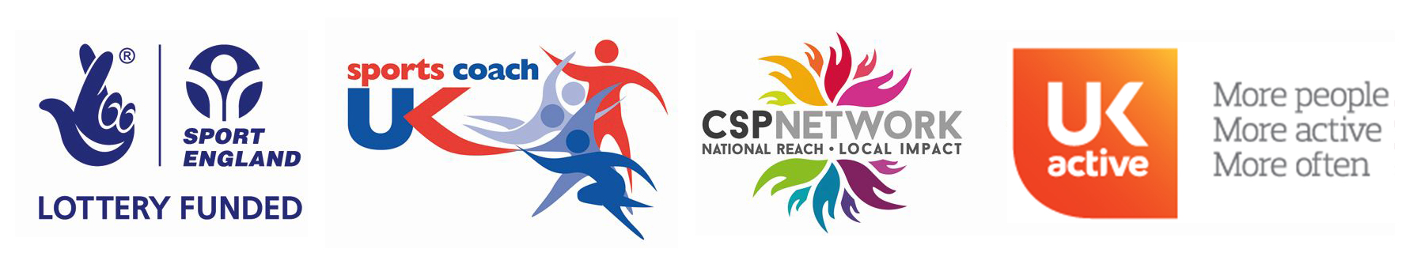
Date:

Review Date: 09/07/2020

